Deep Learning Enabled Diabetic Retinopathy Diagnosis Using Retinal Fundus Images

ABSTRACT
In this study, a MATLAB-based system is developed for automated classification of eye diseases, specifically targeting Diabetic Retinopathy (DR). The process begins with an input image undergoing preprocessing steps, including resizing, noise removal, contrast enhancement, and segmentation using Mayfly Optimization-based Region Growing (MFORG) to isolate relevant regions. The system initially classifies the image as either healthy or indicative of DR. For detected DR cases, a further stage-wise classification is performed to identify the severity level: Mild DR, Moderate DR, Severe DR, or Proliferative DR (PDR). This classification leverages advanced image processing techniques and a DenseNet deep learning model, ensuring high accuracy and reliability. Additionally, the processed data and classification results are transmitted to a ThingSpeak channel for real-time monitoring and visualization, enabling remote access for healthcare professionals. This approach demonstrates the integration of optimization algorithms, deep learning, and IoT platforms to create a robust and efficient solution for early detection and severity assessment of Diabetic Retinopathy, contributing significantly to improving patient care and management.
Keywords: Fungus Dataset, Deep Learning, Convolution Neural Network, Image Processing Techniques, segmentation and accuracy.

CHAPTER 1
INTRODUCTION
Fundus imaging has a rich history, dating back to the late 19th century when the first ophthalmoscope was developed by Hermann von Helmholtz in 1851, allowing doctors to examine the interior surface of the eye, including the retina, optic disc, macula, and posterior pole. Over time, advancements in fundus photography have revolutionized the diagnosis and management of various ocular diseases, particularly diabetic retinopathy (DR). Fundus images provide a detailed view of the retinal vasculature, enabling the identification of abnormalities caused by diabetes. Diabetic retinopathy progresses through several stages, starting with Mild Non-Proliferative Diabetic Retinopathy (NPDR), characterized by microaneurysms and small hemorrhages. As the disease advances, Moderate and Severe NPDR stages emerge, with more widespread retinal hemorrhages, venous beading, and intraretinal microvascular abnormalities (IRMA). The final stage, Proliferative Diabetic Retinopathy (PDR), is marked by the growth of new, fragile blood vessels on the retina or optic disc, leading to severe vision loss if untreated. The development of automated systems for the detection and classification of DR stages from fundus images is crucial for early intervention, reducing the risk of vision impairment in diabetic patients through timely diagnosis and treatment.
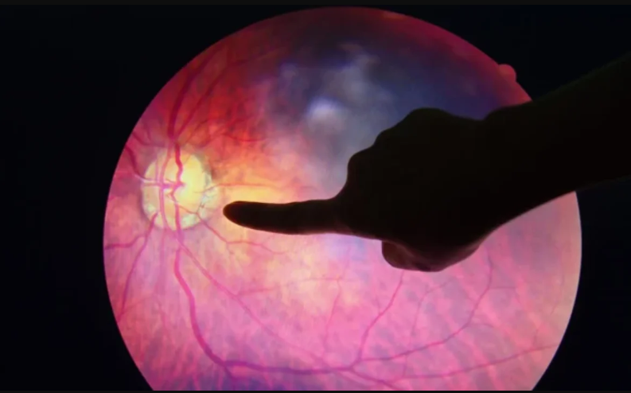
Diabetic retinopathy is an eye disease that affects people living with diabetes. It develops when high blood sugar damages the tiny blood vessels in the retina. This causes a variety of symptoms like blurry vision and vision loss.
What causes diabetic retinopathy?
Glucose, or blood sugar, is a main source of energy — yet too much circulating in the blood can be harmful to the body. Typically, the pancreas releases the hormone insulin, which helps cells absorb glucose for energy. In the case of diabetes, though, the body doesn’t make enough insulin or doesn’t use it properly. This causes glucose to accumulate in the blood.
Consistent levels of high blood sugar can affect different parts of the body, including the eyes. Diabetic retinopathy doesn’t only weaken or damage the blood vessels in the eye. It can also cause the development of new abnormal blood vessels in the retina.
What are stages of diabetic retinopathy?
Diabetic retinopathy is a progressive eye disease classified by two types and four stages.
The two types are nonproliferative and proliferative. Nonproliferative refers to early stages of the disease, while proliferative is an advanced form of the disease.
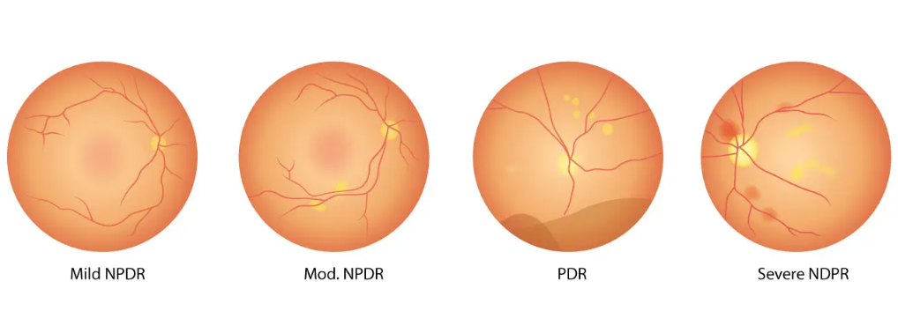
Stage 1: Mild nonproliferative diabetic retinopathy
This is the earliest stage of diabetic retinopathy, characterized by tiny areas of swelling in the blood vessels of the retina. These areas of swelling are known as micro aneurysms.
Small amounts of fluid can leak into the retina at the stage, triggering swelling of the macula. This is an area near the center of the retina.
Stage 2: Moderate nonproliferative diabetic retinopathy
Increased swelling of tiny blood vessels starts to interfere with blood flow to the retina, preventing proper nourishment. This causes an accumulation of blood and other fluids in the macula.
Stage 3: Severe nonproliferative diabetic retinopathy
A larger section of blood vessels in the retina become blocked, causing a significant decrease in blood flow to this area. At this point, the body receives signals to start growing new blood vessels in the retina.
Stage 4: Proliferative diabetic retinopathy
This is an advanced stage of the disease, in which new blood vessels form in the retina. Since these blood vessels are often fragile, there’s a higher risk of fluid leakage. This triggers different vision problems such as blurriness, reduced field of vision, and even blindness.
What are the symptoms of diabetic retinopathy?
Diabetic retinopathy doesn’t usually cause symptoms during the nonproliferative stages, so it’s possible to have it and not know it. This is because blood vessels don’t always leak in these stages.
Many people don’t have symptoms until the disease progresses to proliferative diabetic retinopathy. However, an eye examination by an eye care specialist or ophthalmologist can detect diabetic retinopathy in its earlier stages, before symptoms become apparent. Symptoms of proliferative diabetic retinopathy include:
- an increased number of eye floaters
- blurry vision
- distorted vision
- poor night vision
- loss of vision
- decreased field of vision
- change in colors
Be mindful, too, that diabetic retinopathy symptoms usually affect both eyes at the same time.
How to treat diabetic retinopathy
Diabetic retinopathy may lead to irreversible vision loss, but it is treatable. Treatment starts with managing blood sugar and diabetes. This includes taking diabetes medication as directed, watching your diet, and increasing physical activity. Keeping blood sugar within a healthy range can slow the progression of vision loss.
Other treatments will depend on the stage or extent of the disease. If caught very early — before damage to the retina occurs — blood sugar management might be the only necessary treatment. Your doctor will continue to monitor your eyes, though, to ensure the disease doesn’t progress.
If you’re in a nonproliferative stage but experience some eye damage, treatment options might include:
- Laser surgery. Laser surgery, called photocoagulation, reduces the drive for abnormal blood vessels and swelling in the retina.
- Eye medications. A steroid injection in the eye can stop inflammation and prevent the formation of new blood vessels. You might also be a candidate for anti-VEGF medication, which can reduce swelling in the macula and improve vision. Doctors administer both treatments as an injection in the eye.
- Vitrectomy. If you have proliferative diabetic retinopathy, you might need an eye surgery called vitrectomy. This surgery treats problems with the retina and vitreous, a jellylike substance in the middle of the eye. The surgery can remove scar tissue, blood or fluid, and some of the vitreous gel so light rays can focus properly on the retina. At the same time, traction in the retina or retinal detachments can be corrected.
Top of Form

CHAPTER 2
LITERATURE SURVEY
[1] L. Ravala and G. K. Rajini, ‘‘Automatic diagnosis of diabetic retinopathy from retinal abnormalities: Improved Jaya-based feature selection and recurrent neural network,’’ Comput. J., vol. 65, no. 7, pp. 1904–1922, Jun. 10, 2021.
Accurate diagnosis of lesions bears the highest significance in the early detection of diabetic retinopathy (DR). In this paper, the combination of intelligent methods is developed for segmenting the abnormalities like ‘hard exudates, hemorrhages, microaneurysm and soft exudates’ to detect the DR. The proposed model involves seven main steps: (a) image pre-processing, (b) optic disk removal (c) blood vessel removal, (d) segmentation of abnormalities, (e) feature extraction, (f) optimal feature selection and (f) classification. The pre-processing of the input retinal fundus image is performed by two operations like contrast enhancement by histogram equalization and filtering by average filtering. For the segmentation of abnormalities, the same Circular Hough Transform followed by Top-hat filtering and Gabor filtering is used. Next, the entropy-scale-invariant feature transform (SIFT), grey level co-occurrence matrices and color morphological features are extracted in feature extraction. The optimally selected features are subjected to the classification part, which uses a modified deep learning algorithm called optimized recurrent neural network (RNN). As the main novelty, the optimal feature selection and optimized RNN depends on an improved meta-heuristic algorithm called fitness oriented improved Jaya algorithm. Hence, the beneficial part of the optimization algorithm improves the feature selection and classification.
Outcomes: Effective segmentation, accurate classification, enhanced diagnosis, improved features, better outcomes.
[2] S. S. Athalye and G. Vijay, ‘‘Taylor series-based deep belief network for automatic classification of diabetic retinopathy using retinal fundus images,’’ Int. J. Imag. Syst. Technol., vol. 32, no. 3, pp. 882–901, May 2022.
The diagnosis of diabetic retinopathy (DR) disease in the early stage is very important to reduce the risk in DR treatment. Different methods are in practice for detecting the lesions automatically with the retinal image. However, detecting the occurrence of exudates in the macular region poses a challenging task in the computer-assisted diagnosis of DR. A robust and computationally efficient model for localizing the lesions and features in the retinal fundus image is processed in this research by proposing the Taylor-based deep belief network (T-based DBN) classifier. Exudates and their contours are determined based on the blood vessel and optic disc segmentation model. The microaneurysms are detected based on the wavelet model, and the lesions are segmented with the thresholding and binarization approach. The proposed T-based DBN is highly effective in classifying the DR, based on the multiple layers associated with the restricted Boltzmann machines (RBM) and multi-layer perceptron (MLP) layer. The proposed T-based DBN is the integration of the Taylor series with the DBN classifier. The proposed T-based DBN produces an accurate detection rate and yields better theoretical error bounds. The performance revealed by the proposed model is evaluated using the metrics, namely specificity, sensitivity, and accuracy, with the values of 90.757%, 92.225%, and 92.122%, respectively.
Outcomes: T-based DBN classifier excels in detecting diabetic retinopathy with high accuracy.

[3] A. S. Jadhav, P. B. Patil, and S. Biradar, ‘‘Optimal feature selection-based diabetic retinopathy detection using improved rider optimization algorithm enabled with deep learning,’’ Evol. Intell., vol. 14, no. 4, pp. 1431–1448, Dec. 2021.
This proposal tempts to develop automated DR detection by analyzing the retinal abnormalities like hard exudates, haemorrhages, Microaneurysm, and soft exudates. The main processing phases of the developed DR detection model is Pre-processing, Optic Disk removal, Blood vessel removal, Segmentation of abnormalities, Feature extraction, Optimal feature selection, and Classification. At first, the pre-processing of the input retinal image is done by Contrast Limited Adaptive Histogram Equalization. The next phase performs the optic disc removal, which is carried out by open-close watershed transformation. Further, the Grey Level thresholding is done for segmenting the blood vessels and its removal. Once the optic disk and blood vessels are removed, segmentation of abnormalities is done by Top hat transformation and Gabor filtering. Further, the feature extraction phase is started, which tends to extract four sets of features like Local Binary Pattern, Texture Energy Measurement, Shanon’s and Kapur’s entropy. Since the length of the feature vector seems to be long, the feature selection process is done, which selects the unique features with less correlation. Moreover, the Deep Belief Network (DBN)-based classification algorithm performs the categorization of images into four classes normal, earlier, moderate, or severe stages. The optimal feature selection is done by the improved meta-heuristic algorithm called Modified Gear and Steering-based Rider Optimization Algorithm (MGS-ROA), and the same algorithm updates the weight in DBN. Finally, the effectual performance and comparative analysis prove the stable and reliable performance of the proposed model over existing models. The performance of the proposed model is compared with the existing classifiers, such as, NN, KNN, SVM, DBN and the conventional Heuristic-Based DBNs, such as PSO-DBN, GWO-DBN, WOA-DBN, and ROA-DBN for the evaluation metrics, accuracy, sensitivity, specificity, precision, FPR, FNR, NPV, FDR, F1 score, and MC. From the results, it is exposed that the accuracy of the proposed MGS-ROA-DBN is 30.1% higher than NN, 32.2% higher than KNN, and 17.1% higher than SVM and DBN. Similarly, the accuracy of the developed MGS-ROA-DBN is 13.8% superior to PSO, 5.1% superior to GWO, 10.8% superior to WOA, and 2.5% superior to ROA.
Outcomes: The MGS-ROA-DBN model improves DR detection accuracy, outperforming NN, KNN, SVM, and DBN.

[4] P. R. R. Chandni, J. Justin, and R. Vanithamani, ‘‘Fundus image enhancement using EAL-CLAHE technique,’’ Adv. Data Inf. Sci., vol. 318, pp. 613–624, Feb. 2022.
In the era of digitalized world, ophthalmic anomalies are one among the common diseases caused by certain unhealthy practices or even hereditary to human beings of all ages. Traditionally, retinal diagnostic techniques involve manual inspections made by healthcare professionals, to detect changes present in the eye. But with time, the disease can produce drastic effects even loss of vision when left unnoticed. So, while dealing with such retinal diagnostic applications, the quality of images is utmost important to determine certain conclusions regarding the disease. Thus, the quality of dataset needs to be standard, or the enhancement techniques deployed must provide betterment for easy disease prediction process. The featured EAL-CLAHE method provides better PSNR, SSIM and NIQE values in comparison with the traditional approaches. The proposed method is effective in reducing non-uniform illumination while preserving its edges. Thus, the implemented system can improve the traditional methodologies.
Outcomes: Using EAL-CLAHE: Improved image quality, higher PSNR, SSIM, NIQE, accurate detection.
[5] B. Bataineh and K. H. Almotairi, ‘‘Enhancement method for color retinal fundus images based on structural details and illumination improvements,’’ Arabian J. Sci. Eng., vol. 46, no. 9, pp. 8121–8135, Feb. 2021.
Retinal images show an essential role in Ophthalmology to diagnosis wide set of diseases. In this direction, using retinal images in computerized techniques increases the ability of diagnosis in fast time effectively. However, some eye diseases and capturing conditions produce low-quality retinal images, which reduces the diagnosis ability for machines and humans. To solve that, several works have been proposed to enhance retinal images. But they show a lot of negative observations, especially with color images of retina. In this paper, a novel enhancement algorithm for color retinal images is proposed. It consists of three stages; firstly, the appearance of visual details is increased by enhancing the contrast of structural details of retinal image using details enhanced and Bilateral filters. Then, a novel uneven illumination correction method is proposed to solve the uneven illumination problem adaptively. Finally, the advantages of both previous stages are combined using HSV color model to produce the final enhanced retinal images. DRIVE and STARE benchmark datasets are used to conduct experiments. The results were compared with histogram Equalized (HE), Contrast Stretching (CS), the adaptive histogram equalization (CLAHE) and Zhou’s method retinal enhancement methods. In conclusion, the results show that the proposed method shows high performance compared with the corresponding enhancement methods.
Outcomes: HSV-based Retinal Image Enhancement Algorithm enhances retinal images, improving contrast and illumination effectively.
[6] B. Yang, H. Zhao, L. Cao, H. Liu, N. Wang, and H. Li, ‘‘Retinal image enhancement with artifact reduction and structure retention,’’ Pattern Recognit., vol. 133, Jan. 2023, Art. no. 108968.
Enhancement of low-quality retinal fundus images is beneficial to clinical diagnosis of ophthalmic diseases and computer-aided analysis. Enhancement accuracy is a challenge for image generation models, especially when there is no supervision by paired images. To reduce artifacts and retain structural consistency for accuracy improvement, we develop an unpaired image generation method for fundus image enhancement with the proposed high-frequency extractor and feature descriptor. Specifically, we summarize three causes of tiny vessel-like artifacts which always appear in other image generation methods. A high frequency prior is incorporated into our model to reduce artifacts by the proposed high-frequency extractor. In addition, the feature descriptor is trained alternately with the generator using segmentation datasets and generated image pairs to ensure the fidelity of the image structure. Pseudo-label loss is proposed to improve the performance of the feature descriptor. Experimental results show that the proposed method performs better than other methods both qualitatively and quantitatively. The enhancement can improve the performance of segmentation and classification in retinal images.
Outcomes: Enhances image quality, reduces artifacts, improves segmentation and classification accuracy.

CHAPTER 3
EXISTING METHOD
Innovation is getting progressed step by step in pretty much every field. This work includes the detection of Diabetic Retinopathy (DR). Diabetes happens when the pancreas neglects to emit sufficient insulin, and gradually influences the retina of the natural eye. As it advances, the vision of a patient begins deteriorating (depleting), prompting diabetic retinopathy. In such manner, retinal pictures gained through fundal camera help in investigating the outcomes, nature, and status of the impact of diabetes on the eye. The main aim of this study is Age-related Macular Degeneration (AMD) through Local Binary Patterns (LBP) and further trial and error utilizing Gray-Level Co-Occurrence Matrix (GLCM). For this reason, the presentation of Gray level Co-Occurrence Matrix (GLCM) as a surface descriptor for retinal pictures has been investigated and contrasted and different descriptors, for example, GLCM filtering (GLCMF) and local phase quantization (LPQ). This will take to the of blood vessel highlights, for example, energy, differentiation, correlation and homogeneity values. We involve SVM as a classifier to recognize valid and bogus vessels. The conclusion of diabetic retinopathy depends on clinical eye assessment and eye fundus imaging.
SVM Classifier:
Support vector machines (SVMs) are a set of supervised learning methods used for classification, regression and outlier’s detection. However, primarily, it is used for Classification problems in Machine Learning. An SVM model is basically a representation of different classes in a hyper plane in multidimensional space. The hyper plane will be generated in an iterative manner by SVM so that the error can be minimized. The goal of the SVM algorithm is to create the best line or decision boundary that can segregate n-dimensional space into classes so that we can easily put the new data point in the correct category in the future. This best decision boundary is called a hyperplane.
What is HOG in image processing?
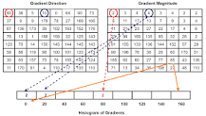
Histogram of Oriented Gradients, also known as HOG, is a feature descriptor like the Canny Edge Detector, SIFT (Scale Invariant and Feature Transform). It is used in computer vision and image processing for the purpose of object detection.
Histogram of Oriented Gradients, also known as HOG, is a feature descriptor like the Canny Edge Detector, SIFT (Scale Invariant and Feature Transform). It is used in computer vision and image processing for the purpose of object detection. The technique counts occurrences of gradient orientation in the localized portion of an image. This method is quite similar to Edge Orientation Histograms and Scale Invariant a Feature Transformation (SIFT). The HOG descriptor focuses on the structure or the shape of an object. It is better than any edge descriptor as it uses magnitude as well as angle of the gradient to compute the features. For the regions of the image, it generates histograms using the magnitude and orientations of the gradient.
What are features?
Features are parts or patterns of an object in an image that help to identify it. For example — a square has 4 corners and 4 edges, they can be called features of the square, and they help us humans identify it’s a square. Features include properties like corners, edges, regions of interest points, ridges, etc.
As shown in the image below the yellow points show the features detected using a technique called Harris Detection.
Glimpse of Traditional feature detection techniques
Traditional Computer Vision techniques for feature detection include:
Harris Corner Detection — Uses a Gaussian window function to detect corners.
Shi-Tomasi Corner Detector — The authors modified the scoring function used in Harris Corner Detection to achieve a better corner detection technique
Scale-Invariant Feature Transform (SIFT) — This technique is scale invariant unlike the previous two.
Speeded-Up Robust Features (SURF) — This is a faster version of SIFT as the name says.
Features from Accelerated Segment Test (FAST) — This is a much more faster corner detection technique compared to SURF.
Binary Robust Independent Elementary Features (BRIEF) — This is only a feature descriptor that can be used with any other feature detector. This technique reduces the memory usage by converting descriptors in floating point numbers to binary strings.
Oriented FAST and Rotated BRIEF (ORB) — SIFT and SURF are patented and this algorithm from OpenCV labs is a free alternative to them, that uses FAST key point detector and BRIEF descriptor.

Introduction to SVM
Support vector machines (SVMs) are powerful yet flexible supervised machine learning algorithms which are used both for classification and regression. But generally, they are used in classification problems. In 1960s, SVMs were first introduced but later they got refined in 1990. SVMs have their unique way of implementation as compared to other machine learning algorithms. Lately, they are extremely popular because of their ability to handle multiple continuous and categorical variables.

Support Vector Machine Algorithm
Support Vector Machine or SVM is one of the most popular Supervised Learning algorithms, which is used for Classification as well as Regression problems. However, primarily, it is used for Classification problems in Machine Learning. The goal of the SVM algorithm is to create the best line or decision boundary that can segregate n-dimensional space into classes so that we can easily put the new data point in the correct category in the future. This best decision boundary is called a hyperplane.
SVM chooses the extreme points/vectors that help in creating the hyperplane. These extreme cases are called as support vectors, and hence algorithm is termed as Support Vector Machine. Consider the below diagram in which there are two different categories that are classified using a decision boundary or hyperplane:
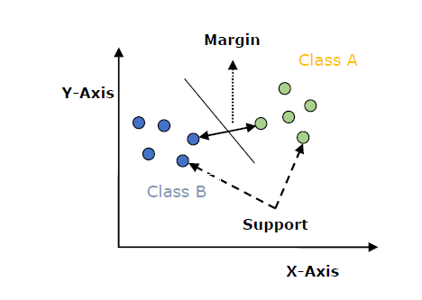
SVM can be understood with the example that we have used in the KNN classifier. Suppose we see a strange cat that also has some features of dogs, so if we want a model that can accurately identify whether it is a cat or dog, so such a model can be created by using the SVM algorithm. We will first train our model with lots of images of cats and dogs so that it can learn about different features of cats and dogs, and then we test it with this strange creature. So as support vector creates a decision boundary between these two data (cat and dog) and choose extreme cases (support vectors), it will see the extreme case of cat and dog. On the basis of the support vectors, it will classify it as a cat.
Disadvantages:
- SVMs may struggle with very large datasets or high-dimensional data, as they can become computationally expensive and time-consuming.
- SVM performance depends on good feature extraction; poor selection leads to errors.
- SVMs need careful adjustment of settings, which can be tricky and slow.

CHAPTER 4
PROPOSED METHOD
The proposed methodology employs MATLAB for the automated detection and classification of Diabetic Retinopathy (DR). The process begins with the input of a retinal image, which undergoes essential preprocessing steps to ensure accurate analysis. Preprocessing includes resizing the image to a uniform dimension, noise removal using filtering techniques to eliminate artifacts, and contrast enhancement to improve the visibility of retinal features. Following this, segmentation is performed using the Mayfly Optimization-based Region Growing (MFORG) algorithm, which efficiently identifies and isolates regions of interest such as microaneurysms, hemorrhages, or exudates indicative of DR. Once preprocessed, the image is analyzed to determine whether it is healthy or exhibits signs of DR. For images classified as DR-positive, a subsequent stage is initiated to classify the severity level into one of four categories: Mild DR, Moderate DR, Severe DR, or Proliferative DR (PDR). This classification leverages image processing techniques in conjunction with a DenseNet deep learning model, known for its capability to extract hierarchical features and deliver precise classifications. The results, including the classification outcome and severity level, are transmitted to a ThingSpeak IoT channel, enabling real-time monitoring and visualization. This integration allows healthcare professionals to remotely access patient data, facilitating timely interventions and continuous tracking of disease progression. The methodology combines advanced optimization, deep learning, and IoT technologies, presenting a comprehensive framework for early detection and management of Diabetic Retinopathy, ultimately enhancing patient outcomes and healthcare efficiency.
.

DR DATASET
Start
Pre-Processing
Dense Net
Input Image
Dataset

Layers

Training Options

Classification

Image Resize

Noise Removal

Enhance Contrast

Mayfly Optimization-based Region Growing (MFORG)

Healthy

Diabetic Retinopathy
Dense Net

Dataset

Layers

Training Options

Classification

- Mild DR
- Moderate DR
- Severe DR
- PDR

Thing Speak Channel (Data Logging)

Send Data to Thing Speak Channel
Real-Time Monitoring & Visualization on Thing Speak

END

Fig: Block Diagram of Proposed Model
Image Resize
In MATLAB, image resizing refers to the process of changing the dimensions of an image, either by enlarging or reducing its width and height, while maintaining or altering its aspect ratio. This technique is commonly applied in image processing tasks to standardize image sizes for further analysis, such as in machine learning models where uniform input dimensions are required. MATLAB provides a built-in function `imresize ()` to perform this operation. The function takes an input image and allows resizing based on a specified scaling factor or desired dimensions. Several interpolation methods are available in MATLAB to determine the pixel values during resizing, including nearest-neighbor, bilinear, and bicubic interpolation. The choice of interpolation affects the quality and smoothness of the resized image; for instance, nearest-neighbor interpolation is faster but can produce blocky results, while bicubic interpolation generates smoother transitions at the cost of higher computational complexity. Resizing an image can be crucial in scenarios where large image sizes can slow down processing times, or when smaller images need to be scaled up for better visualization. Additionally, resizing is essential in deep learning applications, where neural networks often require input images of consistent sizes to ensure accurate training and prediction.
Noise Removal:
In MATLAB, noise removal is an essential image processing technique used to enhance the quality of an image by reducing unwanted random variations, known as noise, that can distort the image data. Noise typically arises during image acquisition, transmission, or storage, and can take many forms, such as Gaussian noise, salt-and-pepper noise, or speckle noise. MATLAB offers several built-in functions to remove noise and improve image clarity. The most common techniques include filtering methods like the median filter (`medfilt2`), which is highly effective for salt-and-pepper noise, and the Gaussian filter (`imgaussfilt`), which smoothens the image by applying a Gaussian kernel. Another approach is Wiener filtering (`wiener2`), an adaptive filter that reduces noise while preserving edges, making it ideal for dealing with Gaussian noise. Additionally, MATLAB’s `imfilter` and `fspecial` functions allow the implementation of custom filters for noise removal. These filters work by convolving the image with a kernel, reducing noise while attempting to retain important details such as edges. Effective noise removal is crucial for preprocessing in image analysis, as it enhances the visibility of features and improves the performance of subsequent tasks like segmentation, feature extraction, and classification in various image processing and computer vision applications.
Enhance Contrast:
In MATLAB, enhancing contrast is a crucial image processing technique used to improve the visual distinction between different regions in an image. Contrast enhancement adjusts the intensity values of pixels in an image to increase the difference between light and dark areas, making specific features more discernible. MATLAB provides several functions to enhance contrast, such as `imadjust`, `histeq`, and `adapthisteq`. The `imadjust` function performs contrast stretching by mapping intensity values to a new range, often spreading out the most frequent intensity values to utilize the full dynamic range of the image. The `histeq` function applies histogram equalization, which redistributes the intensity levels of the image so that the histogram of the output image is approximately flat, improving the contrast, especially in low-contrast images. The `adapthisteq` function performs contrast-limited adaptive histogram equalization (CLAHE), which enhances the contrast of the image locally rather than globally, making it particularly effective for images with non-uniform lighting or brightness variations. These contrast enhancement techniques are commonly used in medical imaging, remote sensing, and object recognition, where improving the visibility of key features can significantly impact the analysis and interpretation of the image.
Mayfly Optimization-based Region Growing (MFORG):
The Mayfly Optimization-based Region Growing (MFORG) algorithm in MATLAB is a novel approach for image segmentation, combining traditional region growing techniques with optimization principles inspired by the behavior of mayflies. This algorithm enhances segmentation accuracy by applying an adaptive thresholding method guided by mayfly-inspired optimization. The `MFORG` function first processes the input image by converting it to the LAB color space, applying Principal Component Analysis (PCA) for dimensionality reduction, and enhancing contrast using adaptive histogram equalization (`adapthisteq`). A smoothing filter is applied to the image using an average filter (`fspecial`), followed by subtracting the smoothed image from the enhanced one to emphasize edges. Thresholding via `graythresh` is then employed to convert the processed image into a binary mask, which is further refined using morphological operations like `bwareaopen` to remove small objects, ensuring that only significant regions are retained. Finally, the segmented regions are overlaid onto the original image in red for clear visualization. The result is a precise segmentation of critical areas within the image, which can be used for further analysis or classification tasks, particularly useful in medical imaging for detecting regions of interest such as lesions or abnormalities. This method improves segmentation accuracy, especially in complex images with varying intensities.
DenseNet:
Convolutional neural networks (CNNs) have been at the forefront of visual object recognition. From the pioneering LeNet to the widely used VGG and ResNets, the quest for deeper and more efficient networks continues. A significant breakthrough in this evolution is the Densely Connected Convolutional Network, or DenseNet, introduced by Gao Huang, Zhuang Liu, Laurens van der Maaten, and Kilian Q. Weinberger. DenseNet’s novel architecture improves information flow and gradient propagation, offering numerous advantages over traditional CNNs and ResNets.

What is DenseNet?
DenseNet, short for Dense Convolutional Network, is a deep learning architecture for convolutional neural networks (CNNs) introduced by Gao Huang, Zhuang Liu, Laurens van der Maaten, and Kilian Q. Weinberger in their paper titled “Densely Connected Convolutional Networks” published in 2017. DenseNet revolutionized the field of computer vision by proposing a novel connectivity pattern within CNNs, addressing challenges such as feature reuse, vanishing gradients, and parameter efficiency. Unlike traditional CNN architectures where each layer is connected only to subsequent layers, DenseNet establishes direct connections between all layers within a block. This dense connectivity enables each layer to receive feature maps from all preceding layers as inputs, fostering extensive information flow throughout the network.

Key Characteristics of DenseNet
- Alleviated Vanishing Gradient Problem: Dense connections ensure that gradients can flow directly to earlier layers, mitigating the vanishing gradient issue common in deep networks.
- Improved Feature Propagation: Each layer has direct access to the gradients from the loss function and the original input signal, promoting better feature propagation.
- Feature Reuse: By concatenating features from all preceding layers, DenseNet encourages feature reuse, reducing redundancy and improving efficiency.
- Reduced Parameters: Despite its dense connections, DenseNet is parameter-efficient. It eliminates the need to relearn redundant features, resulting in fewer parameters compared to traditional networks.
Architecture of DenseNet
DenseNet introduces a paradigm shift by connecting each layer to every other layer in a feed-forward manner. Unlike traditional CNNs, which have a single connection between consecutive layers, DenseNet ensures that each layer receives inputs from all preceding layers and passes its output to all subsequent layers. This results in a network with L(L+1)/2 direct connections for L layers, significantly enhancing information flow.
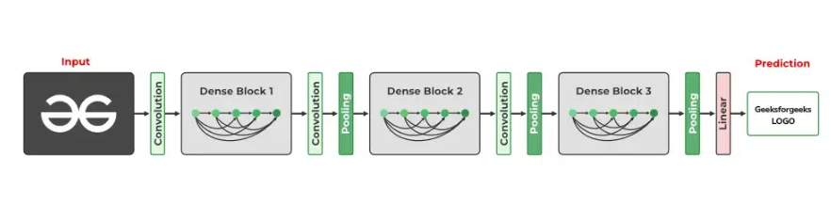

Dense Block
Dense blocks are the building blocks of DenseNet architectures. Each dense block consists of multiple convolutional layers, typically followed by batch normalization and a non-linear activation function (e.g., ReLU). Importantly, each layer within a dense block receives feature maps from all preceding layers as inputs, facilitating feature reuse and propagation.
Within a dense block, each layer receives the concatenated output of all preceding layers as its input. If a dense block has m layers, and each layer produces k feature maps (where k is known as the growth rate), the l-th layer will have 𝑘×(𝑙+𝑙0)k×(l+l0​) input feature maps (where 𝑙0l0​ is the number of input channels to the dense block).

Example of a Dense Block:
- Layer 1: Receives input feature maps.
- Layer 2: Receives input feature maps + output of Layer 1.
- Layer 3: Receives input feature maps + output of Layer 1 + output of Layer 2.
This pattern continues for all layers within the block, ensuring a highly interconnected architecture.

Transition Layer
Transition layers are used to connect dense blocks. They serve two main purposes: reducing the number of feature maps and downsampling the spatial dimensions of the feature maps. This helps in maintaining the computational efficiency and compactness of the network. A typical transition layer consists of:

- Batch Normalization: Normalizes the feature maps.
- 1×1 Convolution: Reduces the number of feature maps.
- Average Pooling: Down samples the spatial dimensions.

DenseNet Variants
DenseNet comes in several variants, distinguished primarily by their depth and number of layers:
- DenseNet-121: Contains 121 layers, known for its balanced trade-off between computational efficiency and accuracy. Ideal for tasks requiring moderate computational resources.
- DenseNet-169: With 169 layers, this variant provides deeper feature extraction, suitable for more complex datasets where higher accuracy is needed.
- DenseNet-201 and DenseNet-264: These variants offer even deeper architectures, suitable for highly complex tasks requiring extensive feature representation.
DenseNet, short for Dense Convolutional Network, is a deep learning architecture renowned for its dense connectivity pattern among layers. Developed to address issues of vanishing gradients and feature reuse in deep neural networks, DenseNet has gained popularity for its efficiency and effectiveness in various computer vision tasks, including image classification and segmentation.
In MATLAB, DenseNet is implemented using the Deep Learning Toolbox, which provides pre-built architectures and tools for customizing and training deep neural networks. The core concept of DenseNet revolves around dense blocks and transition layers. Dense blocks consist of multiple densely connected convolutional layers, where each layer receives feature maps from all preceding layers as inputs. This dense connectivity fosters feature reuse and facilitates gradient flow throughout the network, thereby improving training efficiency and model performance.
Within each dense block, layers are typically organized into composite units called DenseNet layers. These units include convolutional layers with batch normalization and ReLU activation functions, which are stacked to form the building blocks of the network. The growth rate parameter dictates the number of output feature maps produced by each layer within the dense block, influencing the network's capacity to learn intricate features.
Transition layers are interspersed between dense blocks to regulate the number of feature maps and spatial dimensions. They typically include batch normalization, followed by 1x1 convolution and average pooling operations. These transitions serve to compress the feature maps, reducing computational complexity and channel redundancy while facilitating efficient information flow across different network depths.
Training Options:

- sgdm (Stochastic Gradient Descent with Momentum): Specifies the optimization algorithm for updating the neural network weights during training.
- ExecutionEnvironment: "auto": Automatically selects the available hardware (CPU or GPU) for training the neural network, optimizing computation resources.
- InitialLearnRate: 0.001: Sets the initial learning rate for the optimization algorithm, determining the step size in weight updates during training.
- MaxEpochs: 100: Specifies the maximum number of training epochs, i.e., the number of passes through the entire training dataset.
- MiniBatchSize: 25: Defines the number of samples in each mini-batch, controlling the frequency of weight updates and impacting training efficiency.
- Shuffle: "every-epoch”: Specifies that the training data should be shuffled before each epoch, preventing the model from memorizing the order of the data.
- ValidationData: augimdsValidation: Sets the validation dataset used to monitor the model's performance during training, aiding in preventing overfitting.
- ValidationFrequency: 50: Determines how often to evaluate the validation set, here after every 50 mini-batches.
- Verbose: true: Enables the display of detailed information about the training progress.
- Plots: "training-progress": Requests the generation of training progress plots, providing visual insights into the model's performance over epochs.
Fully Connected Layer
Create a fully connected layer using fullyConnectedLayer. A fully connected layer multiplies the input by a weight matrix and then adds a bias vector. The convolutional (and down-sampling) layers are followed by one or more fully connected layers. As the name suggests, all neurons in a fully connected layer connect to all the neurons in the previous layer. This layer combines all of the features (local information) learned by the previous layers across the image to identify the larger patterns. For classification problems, the last fully connected layer combines the features to classify the images. This is the reason that the output Size argument of the last fully connected layer of the network is equal to the number of classes of the data set. For regression problems, the output size must be equal to the number of response variables.
You can also adjust the learning rate and the regularization parameters for this layer using the related name-value pair arguments when creating the fully connected layer. If you choose not to adjust them, then trainNetwork uses the global training parameters defined by the training Options function. For details on global and layer training options.
Output Layers
Softmax and Classification Layers
A softmax layer applies a softmax function to the input. Create a softmax layer using SoftMax Layer. A classification layer computes the cross-entropy loss for classification and weighted classification tasks with mutually exclusive classes. Create a classification layer using classificationLayer.
For classification problems, a softmax layer and then a classification layer usually follows the final fully connected layer.
The output unit activation function is the softmax function:
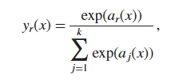
Were,
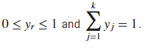
The softmax function is the output unit activation function after the last fully connected layer for multi-class classification problems:
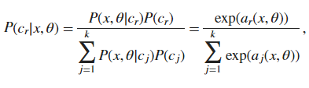
Where, the conditional probability of the sample given class r, and P(c_{r}) is the class prior probability.
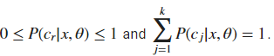
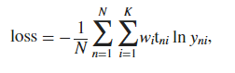
where N is the number of samples, K is the number of classes, wi is the weight for class i, t_{ni} is the indicator that the nth sample belongs to the ith class, and y_{ni} is the output for sample n for class i, which in this case, is the value from the softmax function. In other words, y_{ni} is the probability that the network associates the nth input with class i.

The final step of the system involves two key actions: sending data to ThingSpeak for visualization and dispatching a report via email to the patient.
1. Data Transmission to ThingSpeak: ThingSpeak is an IoT analytics platform that allows users to visualize and analyze live data in real time. By sending the processed data to ThingSpeak, the system enables continuous monitoring of the patient's condition. This platform provides visual representations of the data, such as graphs and charts, making it easier for healthcare providers and patients to understand the progression of diabetic retinopathy or macular edema over time. The integration with ThingSpeak facilitates the collection of ongoing data, allowing for trend analysis and timely interventions if necessary.

2. Email Report and Recommendations: Alongside data visualization, the system generates a comprehensive report summarizing the patient's diagnosis, including the classification of diabetic retinopathy stages and the presence of macular edema. This report is then sent to the patient’s email, providing them with valuable information about their condition. Additionally, the system suggests treatment options and lifestyle recommendations tailored to the patient’s specific needs, encouraging proactive management of their health. This dual approach of visual data analysis and personalized communication enhances patient engagement and supports informed decision-making in their treatment journey.
Accuracy:
In MATLAB, "Accuracy" is a common performance metric used to evaluate the overall effectiveness of a classification model, particularly in binary or multi-class classification tasks. It measures the proportion of correctly classified samples over the total number of samples in the dataset. To understand Accuracy, it's essential to know the concepts of True Positives (TP), False Positives (FP), True Negatives (TN), and False Negatives (FN):

- True Positives (TP): The number of samples correctly classified as positive by the classifier.
- False Positives (FP): The number of negative samples that were incorrectly classified as positive by the classifier.
- True Negatives (TN): The number of samples correctly classified as negative by the classifier.
- False Negatives (FN): The number of positive samples that were incorrectly classified as negative by the classifier.

Accuracy is calculated using the following formula:

Accuracy = (TP + TN) / (TP + TN + FP + FN)

In other words, Accuracy is the ratio of the correctly classified samples (both positive and negative) to the total number of samples in the dataset.
A high Accuracy value indicates that the classifier is performing well and correctly identifying the majority of the samples. However, Accuracy alone may not be the best metric to evaluate the model's performance, especially in imbalanced datasets where one class significantly outnumbers the other. In such cases, a classifier can achieve high Accuracy by simply predicting the majority class, even if it fails to correctly classify the minority class.
CHAPTER 5
ADVANTAGES AND APPLICATIONS
Advantages:
- The system helps identify Diabetic Retinopathy at an early stage, improving chances of timely treatment.
- Advanced algorithms and DenseNet provide precise classification of DR severity levels.
- Integration with ThingSpeak enables real-time access to results for doctors and patients.
- The process is automated, reducing the need for manual analysis and saving time for healthcare professionals.
Applications:
- Diabetic Retinopathy Screening: Helps doctors detect diabetic retinopathy early for timely treatment.
- Macular Edema Detection: Identifies and assesses macular edema from retinal images.
- Clinical Research: Assists in studying diabetic retinopathy progression and treatment effectiveness.
- Patient Monitoring: Tracks patient conditions and treatments in real-time using ThingSpeak.
- Educational Tool: Teaches medical professionals about retinal diseases and image analysis.

CHAPTER – 6
RESULTS
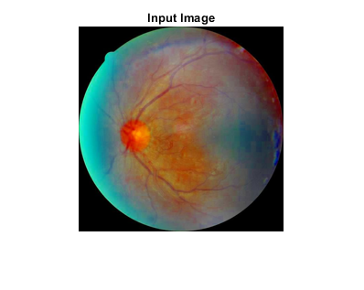
Fig: Input Image
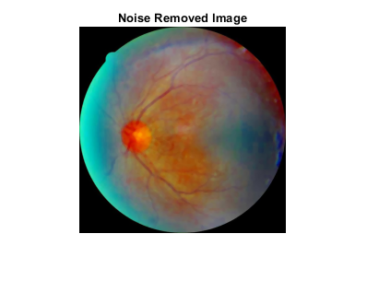
Fig: Noise Removed Image
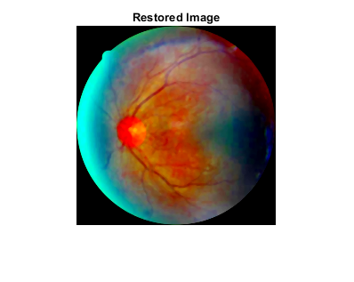
Fig: Restored Image
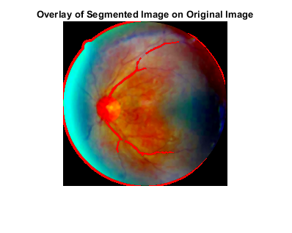
Fig: Overlay of Segmented Image on Original Image
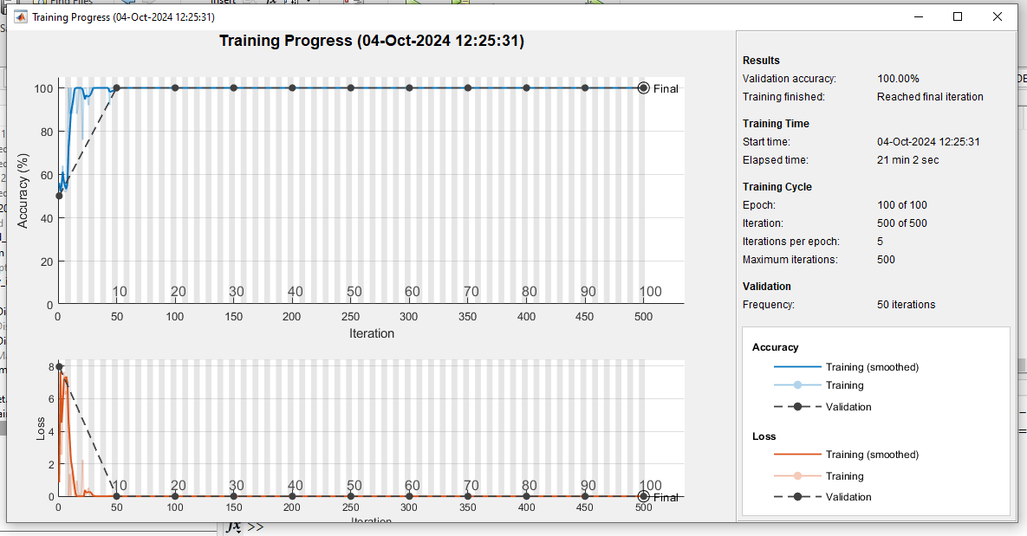
Fig: Training Progress Image
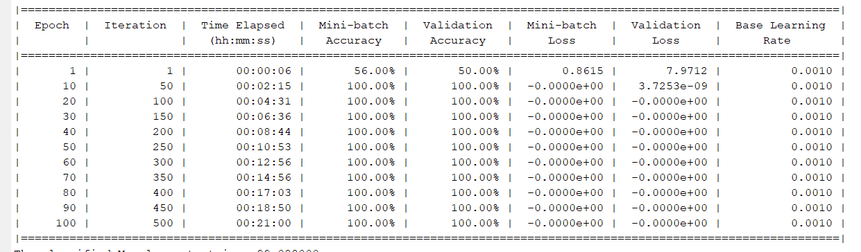
Fig: Training Iterations Image

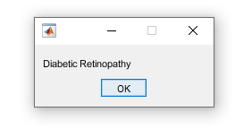
Fig: DR Classification Image
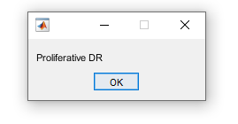
Fig: DR Disease Classification Image

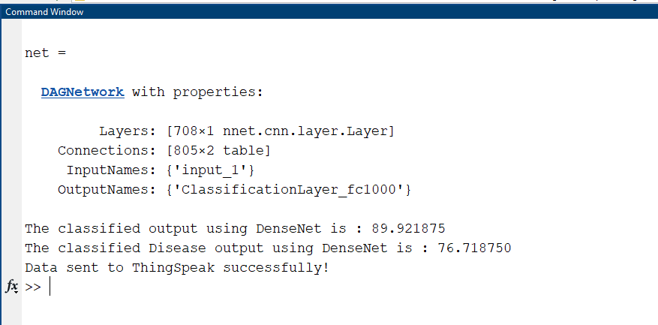
Fig: Metric Values
ThingSpeak Data Visualization:
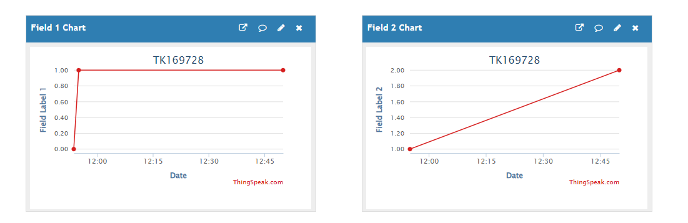
Fig: ThingSpeak Data Visualization

CHAPTER 7
CONCLUSION
In conclusion, the proposed methodology demonstrates an effective, automated approach for the detection and classification of Diabetic Retinopathy (DR) using MATLAB, integrating advanced image processing, deep learning, and IoT technologies. The multi-stage process ensures precision, beginning with robust preprocessing steps to enhance image quality, followed by segmentation using the Mayfly Optimization-based Region Growing (MFORG) algorithm to isolate key pathological features. Leveraging the DenseNet deep learning model, the system accurately classifies retinal images as healthy or DR-positive and further categorizes DR severity into Mild, Moderate, Severe, or Proliferative DR. The integration with ThingSpeak IoT channels facilitates real-time monitoring, enabling healthcare professionals to access patient data remotely, ensuring timely interventions and efficient disease management. This comprehensive framework addresses the critical need for early detection and personalized monitoring of DR, significantly contributing to improved patient outcomes and reducing the burden on healthcare systems. By combining state-of-the-art techniques with IoT-based accessibility, the methodology provides a scalable and efficient solution for tackling one of the leading causes of preventable blindness worldwide.

REFERENCES
[1] L. Ravala and G. K. Rajini, ‘‘Automatic diagnosis of diabetic retinopathy from retinal abnormalities: Improved Jaya-based feature selection and recurrent neural network,’’ Comput. J., vol. 65, no. 7, pp. 1904–1922, Jun. 10, 2021.
[2] S. S. Athalye and G. Vijay, ‘‘Taylor series-based deep belief network for automatic classification of diabetic retinopathy using retinal fundus images,’’ Int. J. Imag. Syst. Technol., vol. 32, no. 3, pp. 882–901, May 2022.
[3] A. S. Jadhav, P. B. Patil, and S. Biradar, ‘‘Optimal feature selection-based diabetic retinopathy detection using improved rider optimization algorithm enabled with deep learning,’’ Evol. Intell., vol. 14, no. 4, pp. 1431–1448, Dec. 2021.
[4] P. R. R. Chandni, J. Justin, and R. Vanithamani, ‘‘Fundus image enhancement using EAL-CLAHE technique,’’ Adv. Data Inf. Sci., vol. 318, pp. 613–624, Feb. 2022.
[5] B. Bataineh and K. H. Almotairi, ‘‘Enhancement method for color retinal fundus images based on structural details and illumination improvements,’’ Arabian J. Sci. Eng., vol. 46, no. 9, pp. 8121–8135, Feb. 2021.
[6] B. Yang, H. Zhao, L. Cao, H. Liu, N. Wang, and H. Li, ‘‘Retinal image enhancement with artifact reduction and structure retention,’’ Pattern Recognit., vol. 133, Jan. 2023, Art. no. 108968.

BIBLIOGRAPHY
Introduction To Matlab
What Is MATLAB?
The name MATLAB stands for Matrix Laboratory. The software is built up around vectors and matrices. This makes the software particularly useful for linear algebra but MATLAB is also a great tool for solving algebraic and differential equations and for numerical integration. MATLAB has powerful graphic tools and can produce nice pictures in both 2D and 3D. It is also a programming language, and is one of the easiest programming languages for writing mathematical programs. These factors make MATLAB an excellent tool for teaching and research.

MATLAB was written originally to provide easy access to matrix software developed by the LINPACK (linear system package) and EISPACK (Eigen system package) projects. It integrates computation, visualization, and programming environment. Furthermore, MATLAB is a modern programming language environment: it has sophisticated data structures, contains built-in editing and debugging tools, and supports object-oriented programming. MATLAB has many advantages compared to conventional computer languages (e.g., C, FORTRAN) for solving technical problems.

MATLAB abilities a family of add-on software program utility software application software program software utility software-unique solutions called toolboxes. Very essential to maximum customers of MATLAB, toolboxes assist you to studies and observe specialized technology. Toolboxes are entire collections of MATLAB abilities (M-files) that increase the MATLAB surroundings to remedy precise schooling of problems. Areas in which toolboxes are to be had embody signal processing, manipulate systems, neural networks, fuzzy correct judgment, wavelets, simulation, and hundreds of others.

It has powerful built-in routines that enable a very wide variety of computations. It also has easy to use graphics commands that make the visualization of results immediately available. Specific applications are collected in packages referred to as toolbox. There are toolboxes for signal processing, symbolic computation, control theory, simulation, optimization, and several other fields of applied science and engineering. MATLAB is an interactive system whose basic data element is an array that does not require dimensioning. The software package has been commercially available since 1984 and is now considered as a standard tool at most universities and industries worldwide.

Brief History of MATLAB:

Cleve Moler, the chairman of the computer science department at the University of New Mexico, started developing MATLAB in the late 1970s. The first MATLAB® was not a programming language; it was a simple interactive matrix calculator. There were no programs, no toolboxes, no graphics and no ODEs or FFTs. He designed it to give his student’s access to LINPACK and EISPACK without them having to learn FORTRAN. It soon spread to other universities and found a strong audience within the applied mathematics community. The mathematical basis for the first version of MATLAB was a series of research papers by J. H. Wilkinson and 18 of his colleagues, published between 1965 and 1970 and later collected in Handbook for Automatic Computation, Volume II, Linear Algebra, edited by Wilkinson and C. Reinsch. These papers present algorithms, implemented in Algol 60, for solving matrix linear equation and Eigen value problems.

In the 1970s and early 1980s, I was teaching Linear Algebra and Numerical Analysis at the University of New Mexico and wanted my students to have easy access to LINPACK and EISPACK without writing FORTRAN programs. By “easy access,” I meant not going through the remote batch processing and the repeated edit-compile-link-load-execute process that was ordinarily required on the campus central mainframe computer. Jack little, an engineer, was exposed to it during a visit Moler made to Stanford University in 1983. Recognizing its commercial potential, he joined with Moler and Steve Bangert. They rewrote MATLAB in C and founded Math Works in 1984 to continue its development. These rewritten libraries were known as JACKPAC. In 2000, MATLAB was rewritten to use a newer set of libraries for matrix manipulation, LAPACK. MATLAB was first adopted by researchers and practitioners in control engineering, little’s specialty, but quickly spread to many other domains. It is now also used in education, in particular the teaching of linear algebra and numerical analysis, and is popular amongst scientists involved in video processing.

EISPACK and LINPACK:
In 1970, a group of researchers at Argonne National Laboratory proposed to the U.S. National Science Foundation (NSF) to “explore the methodology, costs, and resources required to produce, test, and disseminate high-quality mathematical software and to test, certify, disseminate, and support packages of mathematical software in certain problem areas.” The group developed EISPACK (Matrix Eigen system Package) by translating the Algol procedures for Eigen value problems in the handbook into FORTRAN and working extensively on testing and portability. The first version of EISPACK was released in 1971 and the second in 1976.
In 1975, four of us Jack Dongarra, Pete Stewart, Jim Bunch, and myself proposed to the NSF another research project that would investigate methods for the development of mathematical software. A byproduct would be the software itself, dubbed LINPACK, for Linear Equation Package. This project was also centered at Argonne. LINPACK originated in FORTRAN; it did not involve translation from Algol. The package contained 44 subroutines in each of four numeric precisions. In a sense, the LINPACK and EISPACK projects were failures. We had proposed research projects to the NSF to “explore the methodology, costs, and resources required to produce, test, and disseminate high-quality mathematical software.” We never wrote a report or paper addressing those objectives. We only produced software.
So, I studied Niklaus Wirth’s book Algorithms + Data Structures = Programs and learned how to parse programming languages. I wrote the first MATLAB an acronym for Matrix Laboratory in FORTRAN, with matrix as the only data type. The project was a kind of hobby, a new aspect of programming for me to learn and something for my students to use. There was never any formal outside support, and certainly no business plan. This first MATLAB was just an interactive matrix calculator. This snapshot of the start-up screen shows all the reserved words and functions. There are only 71. To add another function, you had to get the source code from me, write a FORTRAN subroutine, add your function name to the parse table, and recompile MATLAB.

Starting MATLAB:

After logging into your account, you can enter MATLAB by double-clicking on the MATLAB shortcut icon (MATLAB 7.0.4) on your Windows desktop. When you start MATLAB, a special window called the MATLAB desktop appears. The desktop is a window that contains other windows. The major tools within or accessible from the desktop are:
- The Command Window
- The Command History
- The Workspace
- The Current Directory
- The Help Browser

Current Folder: This panel allows you to access the project folders and files.

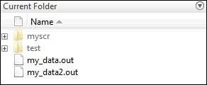

Command Window: This is the main area where commands can be entered at the command line. It is indicated by the command prompt (>>).
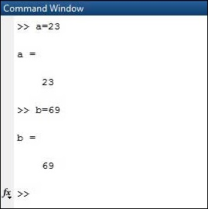

Workspace: The workspace shows all the variables created and/or imported from files.

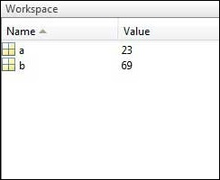

Command History: This panel shows or return commands that are entered at the command line.

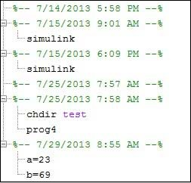

Help Browser:
The critical way to get assist online is to use the MATLAB help browser, opened as a separate window every through clicking at the question mark photograph (?) on the computing tool toolbar, or through manner of typing assist browser on the spark off in the command window. The assist Browser is an internet browser blanketed into the MATLAB computing tool that shows a Hypertext Markup Language (HTML) file. The Help Browser consists of panes, the help navigator pane, used to find out information, and the show pane, used to view the information. Self-explanatory tabs apart from navigator pane are used to performs are searching out.

MATLAB language:

This is a high-level matrix/array language with control flow statements, functions, data structures, input/output, and object-oriented programming features. It allows both "programming in the small" to rapidly create quick and dirty throw-away programs, and "programming in the large" to create complete large and complex application programs.

MATLAB working environment:
This is the set of tools and facilities that you work with as the MATLAB user or programmer. It includes facilities for managing the variables in your workspace and importing and exporting data. It also includes tools for developing, managing, debugging, and profiling M-files, MATLAB's applications.

MATLAB mathematical function library:
This is a vast collection of computational algorithms ranging from elementary functions like sum, sine, cosine, and complex arithmetic, to more sophisticated functions like matrix inverse, matrix eigenvalues, Bessel functions, and fast Fourier transforms.

MATLAB Application Program Interface (API):

This is a library that allows you to write C and FORTRAN programs that interact with MATLAB. It includes facilities for calling routines from MATLAB (dynamic linking), calling MATLAB as a computational engine, and for reading and writing MAT-files.

MATLAB DESKTOP:
MATLAB Desktop is the precept MATLAB utility window. The computing tool includes five sub home windows, the command window, the workspace browser, the modern-day-day list window, the command records window, and one or greater decide domestic windows, which is probably confirmed high-quality on the identical time due to the truth the client suggests a photo. The command window is in which the character types MATLAB instructions and expressions at the spark off (>>) and in which the output of these commands is displayed. MATLAB defines the workspace because the set of variables that the client creates in a bit consultation. The workspace browser suggests those variables and some facts about them. Double clicking on a variable within the workspace browser launches the Array Editor, which may be used to gain statistics and profits instances edit exceptional homes of the variable.

The modern-day-day-day Directory tab above the workspace tab suggests the contents of the cutting-edge list, whose path is shown inside the modern-day list window. For example, in the home windows on foot machine the path is probably as follows: C: MATLAB Work, indicating that listing “artwork” is a subdirectory of the number one list “MATLAB”; WHICH IS INSTALLED IN DRIVE C. Clicking on the arrow within the modern list window suggests a listing of these days used paths. Clicking at the button to the right of the window permits the individual to trade the present-day listing. MATLAB uses a seeking out path to find out M-documents and one-of-a-type MATLAB associated documents, which can be put together in directories within the computer document tool. Any report run in MATLAB need to be dwelling in the modern-day-day listing or in a list that is on is looking for course. By default, the documents supplied with MATLAB and math works toolboxes are included inside the searching out direction. The first-rate manner to look which directories are on the searching out route. The satisfactory manner to appearance which directories are speedy the quest route, or to characteristic or regulate a searching for course, is to pick out outset path from the File menu the computing device, and then use the set course talk discipline. It is proper exercise to feature any generally used directories to the hunt route to avoid again and again having the exchange the cutting-edge-day listing.

The Command History Window contains a file of the instructions a person has entered in the command window, together with every contemporary-day and former MATLAB periods. Previously entered MATLAB instructions can be determined on and re-completed from the command statistics window thru proper clicking on a command or series of commands. This movement launches a menu from which to select numerous options similarly to executing the commands. This is useful to select out abilities options in addition to executing the instructions. This is a beneficial feature at the equal time as experimenting with numerous commands in a piece session.
Using the MATLAB Editor to create M-Files:
The MATLAB editorial manager is a literary substance proofreader particular for growing M-facts and a graphical MATLAB debugger. The supervisor can seem in a window through command facts technique for itself, or it is probably a right-clicking inside the PC. M-information this gadget signified through the use of the expansion .M, as in pixel up.M. The MATLAB editorial supervisor window has a few draws down menus for obligations collectively with sparing, seeing, and troubleshooting facts. Since it plays more than one easy test and furthermore affects utilization of shade to separate among exclusive variables of code, this article editorial supervisor is often supported due to reality the system of a need for composing and altering M-talents. To open the manager, type at enact opens the M-document filename. M in a supervisor window, sorted out for enhancing. As stated earlier than, the file should be inside the cutting-edge posting, or in a posting in the seeking out direction.

Features of MATLAB:
Following are the basic features of MATLAB.
- It is a high-level language for numerical computation, visualization and application development.
- It also provides an interactive environment for iterative exploration, design and problem solving.
- It provides vast library of mathematical functions for linear algebra, statistics, Fourier analysis, filtering, optimization, numerical integration and solving ordinary differential equations.
- It provides built-in graphics for visualizing data and tools for creating custom plots.
- MATLAB's programming interface gives development tools for improving code quality maintainability and maximizing performance.
- It provides tools for building applications with custom graphical interfaces.
- It provides functions for integrating MATLAB based algorithms with external applications and languages such as C, Java, .NET and Microsoft Excel.

Uses of MATLAB:
MATLAB is widely used as a computational tool in science and engineering encompassing the fields of physics, chemistry, math and all engineering streams. It is used in a range of applications including
- Signal Processing and Communications
- Video and Video Processing
- Control Systems
- Test and Measurement
- Computational Finance
- Computational Biology

Applications of MATLAB:
MATLAB can be used as a tool for simulating various electrical networks but the recent developments in MATLAB make it a very competitive tool for Artificial Intelligence, Robotics, Video processing, Wireless communication, Machine learning, Data analytics and whatnot. Though it’s mostly used by circuit branches and mechanical in the engineering domain to solve a basic set of problems its application is vast. It is a tool that enables computation, programming and graphically visualizing the results. The basic data element of MATLAB as the name suggests is the Matrix or an array. MATLAB toolboxes are professionally built and enable you to turn your imaginations into reality. MATLAB programming is quite similar to C programming and just requires a little brush up of your basic programming skills to start working with.

Below are a few applications of MATLAB –

- Statistics and machine learning (ML)
This toolbox in MATLAB can be very handy for the programmers. Statistical methods such as descriptive or inferential can be easily implemented. So is the case with machine learning. Various models can be employed to solve modern-day problems. The algorithms used can also be used for big data applications.

- Curve fitting
The curve fitting toolbox helps to analyze the pattern of occurrence of data. After a particular trend which can be a curve or surface is obtained, its future trends can be predicted. Further plotting, calculating integrals, derivatives, interpolation, etc. can be done.

- Control systems
Systems nature can be obtained. Factors such as closed-loop, open-loop, its controllability and observability, Bode plot, NY Quist plot, etc. can be obtained. Various controlling techniques such as PD, PI and PID can be visualized. Analysis can be done in the time domain or frequency domain.

- Signal Processing
Signals and systems and digital signal processing are taught in various engineering streams. But MATLAB provides the opportunity for proper visualization of this. Various transforms such as Laplace, Z, etc. can be done on any given signal. Theorems can be validated. Analysis can be done in the time domain or frequency domain. There are multiple built-in functions that can be used.

- Mapping
Mapping has multiple applications in various domains. For example, in Big Data, the Map Reduce tool is quite important which has multiple applications in the real world. Theft analysis or financial fraud detection, regression models, contingency analysis, predicting techniques in social media, data monitoring, etc. can be done by data mapping.

- Deep learning
It’s a subclass of machine learning which can be used for speech recognition, financial fraud detection, and medical video analysis. Tools such as time-series, Artificial neural network (ANN), Fuzzy logic or combination of such tools can be employed.

- Financial analysis
An entrepreneur before starting any endeavor needs to do a proper survey and the financial analysis in order to plan the course of action. The tools needed for this are all available in MATLAB. Elements such as profitability, solvency, liquidity, and stability can be identified. Business valuation, capital budgeting, cost of capital, etc. can be evaluated.

- Video processing
The most common application that we observe almost every day are bar code scanners, selfie (face beauty, blurring the background, face detection), video enhancement, etc. The digital video processing also plays quite an important role in transmitting data from far off satellites and receiving and decoding it in the same way. Algorithms to support all such applications are available.

- Text analysis
Based on the text, sentiment analysis can be done. Google gives millions of search results for any text entered within a few milliseconds. All this is possible because of text analysis. Handwriting comparison in forensics can be done. No limit to the application and just one software which can do this all.

- Electric vehicles designing
Used for modeling electric vehicles and analyze their performance with a change in system inputs. Speed torque comparison, designing and simulating of a vehicle, whatnot.

- Aerospace
This toolbox in MATLAB is used for analyzing the navigation and to visualize flight simulator.

- Audio toolbox
Provides tools for audio processing, speech analysis, and acoustic measurement. It also provides algorithms for audio and speech feature extraction and audio signal transformation.

DIGITAL IMAGE/VIDEO PROCESSING
Digital image processing:
Digital Image Processing means processing digital image by means of a digital computer. We can also say that it is a use of computer algorithms, in order to get enhanced image either to extract some useful information.
Image:
An image is defined as a two-dimensional function, F(x, y), where x and y are spatial coordinates, and the amplitude of F at any pair of coordinates (x, y) is called the intensity of that image at that point. When x, y, and amplitude values of F are finite, we call it a digital image. In other words, an image can be defined by a two-dimensional array specifically arranged in rows and columns. Image is composed of a finite number of elements, each of which elements have a particular value at a particular location. These elements are referred to as picture elements, image elements, and pixels.
A Pixel is most widely used to denote the elements of an Image. To be processed digitally, it has to be sampled and transformed into a matrix of numbers. Since a computer represents the numbers using finite precision, these numbers have to be quantized to be represented digitally. Digital image processing consists of the manipulation of those finite precision numbers. The processing of digital images can be divided into several classes: image enhancement, image restoration, image analysis, and image compression.

How a digital image is formed?
Since capturing an image from a camera is a physical process. The sunlight is used as a source of energy. A sensor array is used for the acquisition of the image. So, when the sunlight falls upon the object, then the amount of light reflected by that object is sensed by the sensors, and a continuous voltage signal is generated by the amount of sensed data. In order to create a digital image, we need to convert this data into a digital form. This involves sampling and quantization. (They are discussed later on). The result of sampling and quantization results in a two-dimensional array or matrix of numbers which are nothing but a digital image.

Image processing mainly include the following steps:
- Importing the image via image acquisition tools.
- Analyzing and manipulating the image.
- Output in which result can be altered image or a report which is based on analyzing that image.
An image can be portrayed as a - dimensional trademark f(x, y), in which x and y are spatial directions, and the sufficiency of any combine of instructions (x, y) is known as the pressure or darkish degree of the image at that inconvenience. Whenever x, y and the abundance estimations off are on the entire confined discrete quantities, we call the picture a virtual photo. The district of DIP alludes to getting ready computerized photo through strategies for to method for MATLAB. Manner of the use of advanced pc. Computerized image incorporates of a confined form of things, every one in every of which has a chosen location and fee. The components are alluded to as pixels.
Vision is the maximum innovative of our sensor, so it isn't sudden that photograph play the unmarried greatest important component in human conviction. Nonetheless, in appraisal to humans, who are controlled to the visible band of the EM variety imaging machines cover nearly the complete EM range, starting from gamma to radio waves. They can highlight also on previews created with the valuable useful manual of benefits that people aren't conscious of accomplice with airship picture. There isn't commonly any present settlement among creators concerning in which photo managing stops and specific associated districts nearby aspect photo evaluation& workstation imaginative and prescient start.
In a few instances a difference is made through the use of characterizing picture handling as an area wherein each the information and yield at a way are snap shots. This is constraining and predominantly manufactured restriction. The district of image investigation (photograph getting to know) is in amongst photograph getting ready and PC imaginative and insightful. There aren't any easy restrictions in the continuum from picture preparing at one prevent to complete ingenious and sensible on the inverse. In any case, one precious worldview is to revel in as a primary challenge three types of automatic procedures in this continuum: low-, mid-, and radical affirmation methodologies. Low-certificate way includes crude obligations which incorporates image preparing to reduce clamor, appraisal improvement and photo cleansing. A low-certificates approach is described through the way that very it inputs and yields are previews.

Mid-degree method on photographs incorporates of commitments which exemplify division, depiction of that question decreases them to a form becoming for pc getting ready and category of man or woman devices. A mid-degree method is portrayed thru technique for the reality that its resources of info broadly speaking are images anyway its yields are residences extricated from the one’s photographs. At lengthy remaining better-degree making ready carries "Making history" of a meeting of analyzed gadgets, as in photo assessment and at a broadened path give up of the continuum performing the psychological abilities often connected with human imaginative and prescient. Computerized image making ready, as formally depicted is utilized accurately in a huge kind of locales of astonishing social and financial price.

PHASES OF IMAGE PROCESSING:
- Acquisition:
It could be as simple as being given an image which is in digital form. The main work involves: a) Scaling b) Color conversion (RGB to Gray or vice-versa).
- Image enhancement:
It is amongst the simplest and most appealing in areas of Image Processing it is also used to extract some hidden details from an image and is subjective.
- Image restoration:
It also deals with appealing of an image but it is objective (Restoration is based on mathematical or probabilistic model or image degradation).
- Color image processing:
It deals with pseudo color and full color image processing color models are applicable to digital image processing.
- Wavelets and Multi-resolution processing:
It is foundation of representing images in various degrees.
- Image compression:
It involves in developing some functions to perform this operation. It mainly deals with image size or resolution.
- Morphological processing:
It deals with tools for extracting image components that are useful in the representation & description of shape.
- Segmentation:
It includes partitioning an image into its constituent parts or objects. Autonomous segmentation is the most difficult task in Image Processing.
- Representation and description:
It follows output of segmentation stage, choosing a representation is only the part of solution for transforming raw data into processed data.
- Object detection and recognition:
It is a process that assigns a label to an object based on its descriptor.

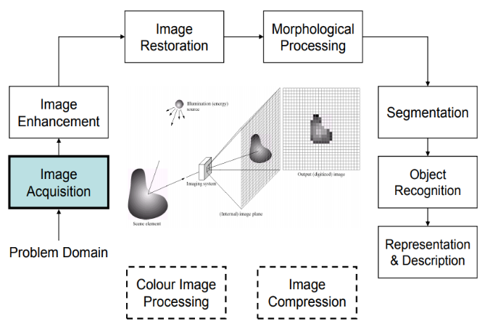

Color image:
It may be spoken to with the aid of techniques for manner of three capacities, R (xylem) for purple, G (xylem) for inexperienced and B (xylem)for blue. An image may be nonstop with renowned to the x and y arranges and moreover in sufficiency. Changing over this type of picture to digital form requires that the guidelines in addition to the adequacy to be digitized. Digitizing the set up's qualities is called analyzing. Digitizing the abundancy esteems is known as quantization.
Grayscale image: ƒ
The image has 8 bits and 256 tons of grey; 1 = black and 255 = white. ƒ Requires 8 times more saving space than a line-art image. Suitable for presenting black and white photographs, for instance. Can be used in printing office.
Image Types:
The tool compartment underpins 4 types of images:
1. Intensity of pixels;
2. Twofold images;
3. Filed images;
4. R G B images.
Most monochrome image making ready sports are finished utilizing parallel or force pix, so our underlying highlight is on this image composes. Filed and RGB shading images.
Intensity Images:
A profundity picture is a measurement lattice whose traits were scaled to talk to goals. At the point while the components of a profundity photo are of class unit8, or elegance unit sixteen, they have complete quantity traits in the collection [0,255] and [0, 65535], for my part. On the off danger that the picture is of class twofold, the qualities are skimming phase numbers. Estimations of scaled, twofold pressure images are within the assortment [0, 1] by means of methods for subculture.
Binary Images:
Double depictions have a completely unique because of this in MATLAB.A parallel photograph is a sensible cluster 0s and1s.Thus, a variety of 1s whose features are of measurements excellence, say unit8, and isn't always concept approximately as a twofold image in MATLAB. A numeric show off is modified to paired the utilization of spotlight coherent. In this manner, if A can be a numeric showcase along problem 1s, we make a cluster B using the announcement.
B=logical (A)
In the event that A contains of elements separated from 0s and 1s. Use of the intelligent capability changes over all nonzero segments to sensible 1s and all sections with rate 0 to coherent 0s. Utilizing social and valid administrators further makes clever well-known shows. To take a look at if a cluster is coherent, we make use of the I practical trademark: is logical(c). In the occasion that c is a coherent show off, this trademark restores a 1. Otherwise returns a zero. Consistent cluster is probably modified over to numeric reveals the utilization of the statistics style transformation presents.
Indexed Images:
Framework define a m*3 kind of magnificence twofold containing skimming trouble esteems within the assortment [0, 1]. The duration m of the guide is identical to the huge sort of shades it characterizes. Each line of manual suggests the blood pink, green and blue brought materials of a solitary shading. Recorded pix make utilization of "coordinate mapping" of pixel electricity esteems shading map esteems. The tinge of every pixel is resolved through way of using the relating rate the whole range grid x as a pointer in to delineate. On the off danger that x is of modernity twofold, at that factor the majority of its segments with values masses substantially less than or indistinguishable to no less than one difficulty to the crucial column in delineate, brought materials with fee 2 thing to the second line et cetera. In the event that x is of complexity devices or unit 16, at that factor all delivered substances fee zero thing to the important line in outline, introduced materials with charge 1 aspect to the second et cetera.

RGB Image:
A RGB shading photograph is a M*N*three exhibit of tinge pixels wherein each coloration pixel is triplet much like the purple, inexperienced and blue brought materials of a RGB image, at a particular spatial area. A RGB image is probably considered as "stack" of three dim scale pics that after advocated in to the darkish pink, green and blue contributions of a tinge display screen. Deliver a shading picture at the show. Tradition the three previews shaping a RGB color image are alluded to as the red, unpracticed and blue brought substances pictures. The information fashion of the brought materials images comes to a decision their form of qualities. On the off hazard that a RGB image is of modernity twofold the type of traits is [0, 1]. Correspondingly the sort of characteristics is [0,255] or [0, 65535]. For RGB pics of modernity gadgets or unit sixteen individually. The form of bits uses to speaks to the pixel estimations of the aspect pictures makes a decision the bit profundity of a RGB photo. For instance, if every aspect image is a 8bit picture, the evaluating RGB photo is expressed to be 24 bits profound. For the most part, the collection of bits in all inconvenience snap shots is the indistinguishable. For this case the type of feasible shading in a RGB photograph is (2^b) ^three, in which in b is numerous bits in the entirety about. For the 8bit case the amount is 16,777,216 colorations.
Advantages of digital image:
- The processing of images is faster and more cost-effective. One needs less time for processing, as well as less film and other photographing equipment. ƒ
- It is more ecological to process images. No processing or fixing chemicals are needed to take and process digital images. However, printing inks are essential when printing digital images.
- When shooting a digital image, one can immediately see if the image is good or not. ƒ copying a digital image is easy, and the quality of the image stays good unless it is compressed.
- For instance, saving an image as jpg format compresses the image. By resaving the image as jpg format, the compressed image will be recompressed, and the quality of the image will get worse with every saving.
- Fixing and retouching of images has become easier. In new Photoshop 7, it is possible to smooth face wrinkles with a new Healing Brush Tool in a couple of seconds.
- The expensive reproduction (compared with restoring the image with a repro camera) is faster and cheaper.
- By changing the image format and resolution, the image can be used in a number of media.

Applications of Digital Image Processing:
Some of the major fields in which digital image processing is widely used are mentioned below.
- Image sharpening and restoration
- Medical field
- Remote sensing
- Transmission and encoding
- Machine/Robot vision
- Color processing
- Pattern recognition
- Video processing
- Microscopic Imaging

